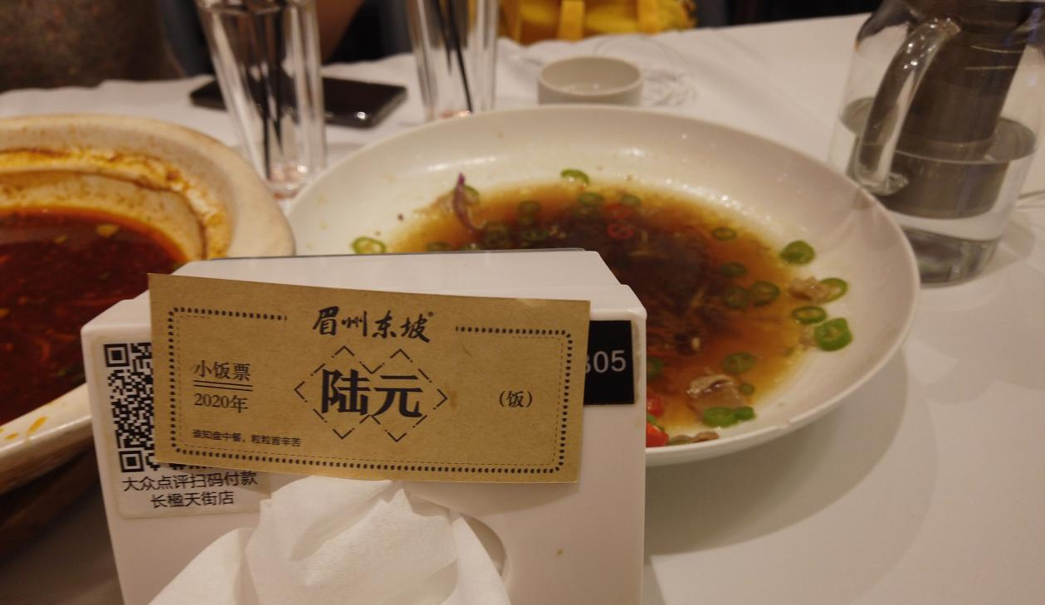

Description: Chen Cheng and her friends finished all the meals they ordered, so Meizhoudongpo rewarded them with a coupon to support the *clear your plate* campaign. The coupon can be used on the next visit.

Date: October 24，2020

Location: Meizhoudongpo Restaurant

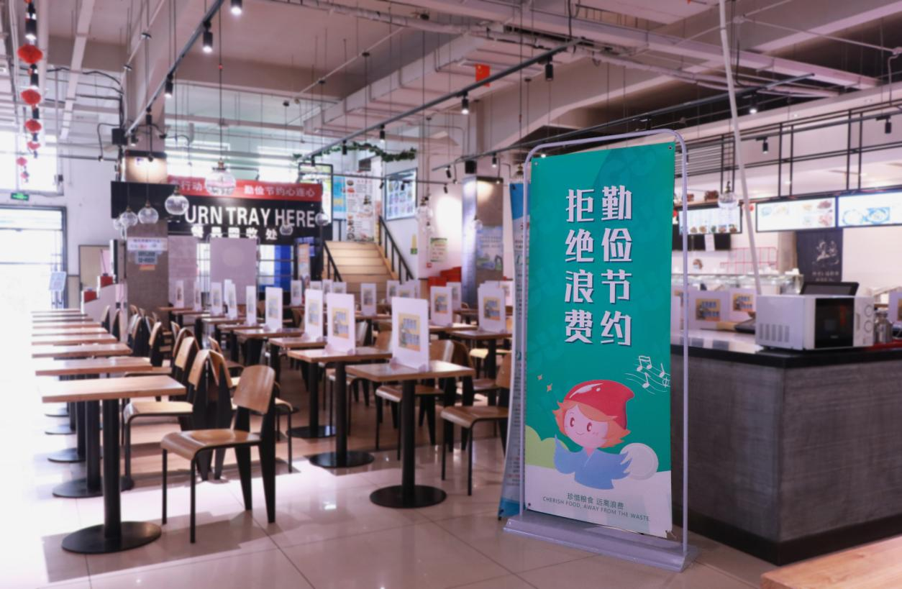

Description: In Communication University of China, the school canteen is full of display stands, posts and banners that call for frugality and not wastefulness.

Date: October 25,2020

Location: The canteen of Communication University of China

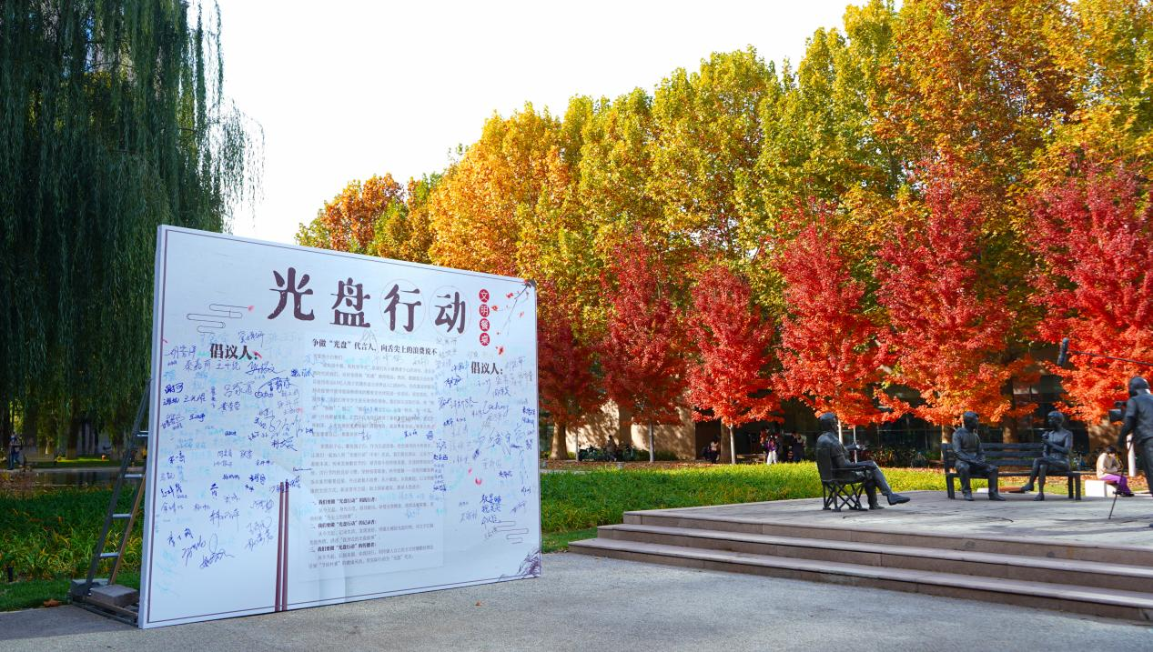

Description:  A large display is placed in the plaza in front of the library. In the middle of the display is an initiative letter on the *clear your plate* campaign. Students who advocate the initiative sign on the display.

Date: October 27,2020

Location: The plaza in front of the library in the campus

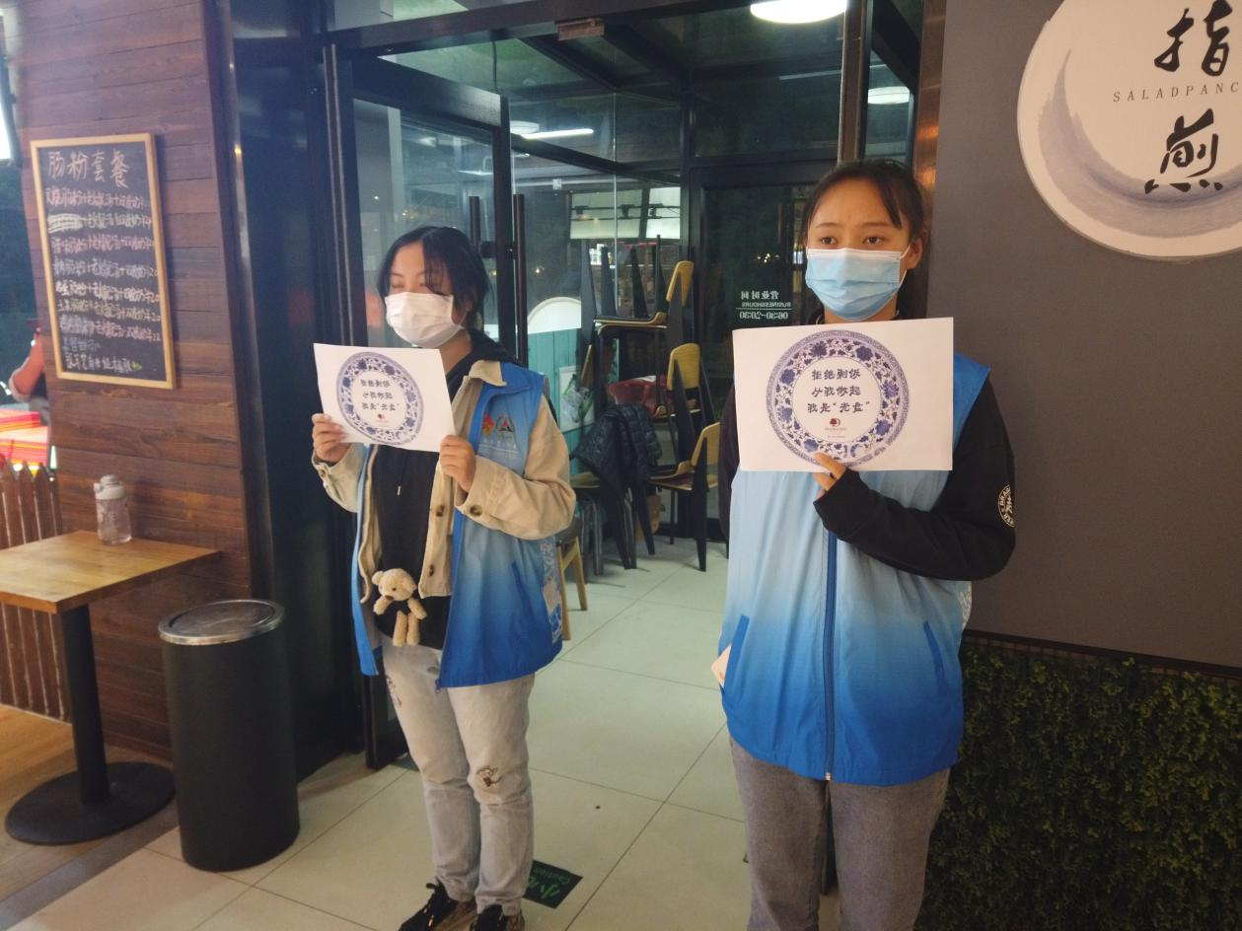

Description: Volunteers holding posters in the school canteen, advising students to take reasonable meals.

Date: October 29,2020

Location: The canteen of Communication University of China